RS-32618 QA Testing 2
RemoveExtensionsRequest API's RefundAmountDue parameter only returns an amount for Final status bookings
<RemoveExtensionsRequest> <MessageHeader> <MessageId>REMEXTREQ</MessageId> <Version>1.0</Version> <UserID>JLIN</UserID> <UserName>jennifer.llin@viking.com</UserName> <UICode>C</UICode> <GDSCode>CS</GDSCode> <AgencyId></AgencyId> <AgentIata></AgentIata> <EmailAddress>jennifer.lin@viking.com</EmailAddress> <SessionID></SessionID> </MessageHeader> <MessageBody> <JSonPayload>{ "Invoice": "9631977", "UserID": "JLIN", "Comment": "", "BypassCancelPenalties": false, "Extensions": [{ "Cruise": "OMA261207", "Code": "213" },{ "Cruise": "OMA261207", "Code": "204", } ] } </JSonPayload> </MessageBody> </RemoveExtensionsRequest>

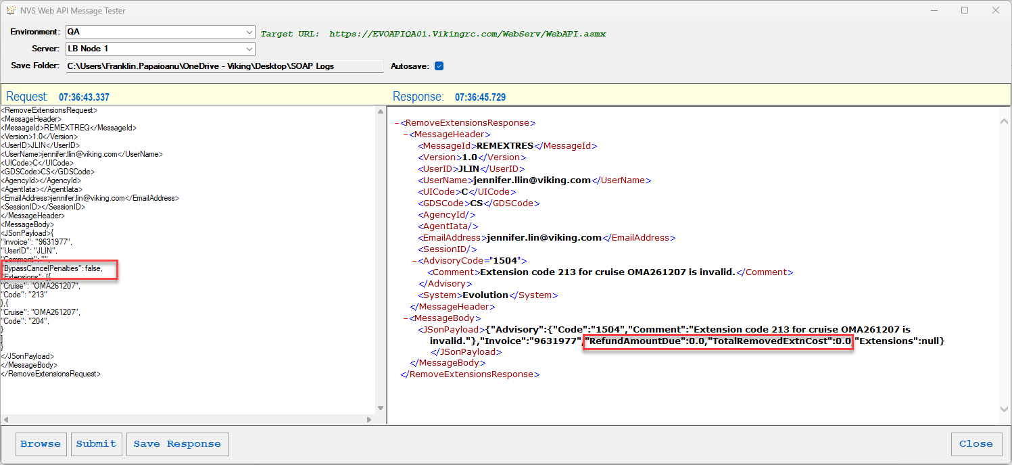
Testing should include: Please verify that the API response has a new parameter ‘TotalRemovedExtnCost’. The parameter should return the sum of the cost of all removed shorex from the booking. All successful removals should be factored into this total, but if a row failed, that amount should not be added into this total.
- Validate removing paid extension(s) from a booking will accurately calculate the TotalRemovedExtnCostas the amount that should go back to the booking

11043690

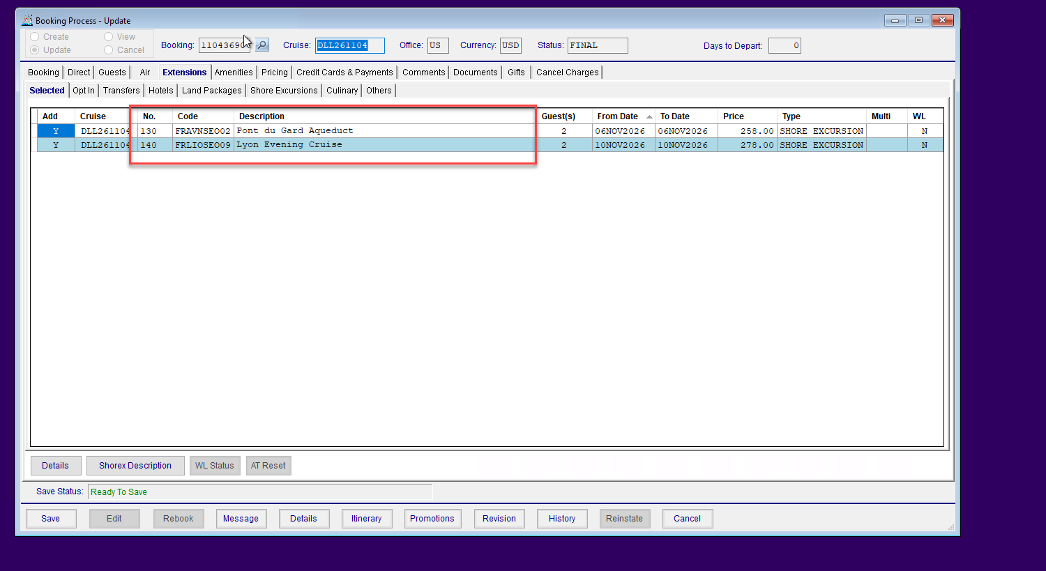
<RemoveExtensionsRequest>
<MessageHeader>
<MessageId>REMEXTREQ</MessageId>
<Version>1.0</Version>
<UserID>FPAPAIOANU</UserID>
<UserName>jennifer.llin@viking.com</UserName>
<UICode>C</UICode>
<GDSCode>CS</GDSCode>
<AgencyId></AgencyId>
<AgentIata></AgentIata>
<EmailAddress>franklin.papaioanu@viking.com</EmailAddress>
<SessionID></SessionID>
</MessageHeader>
<MessageBody>
<JSonPayload>{
"Invoice": "11043690",
"UserID": "FPAPAIOANU",
"Comment": "",
"BypassCancelPenalties": false,
"Extensions": [{
"Cruise": "DLL261104",
"Code": "130"
},{
"Cruise": "DLL261104",
"Code": "140",
}
]
}
</JSonPayload>
</MessageBody>
</RemoveExtensionsRequest>

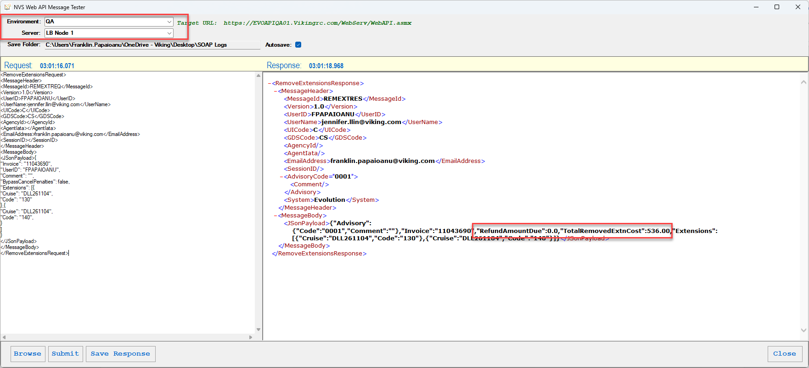
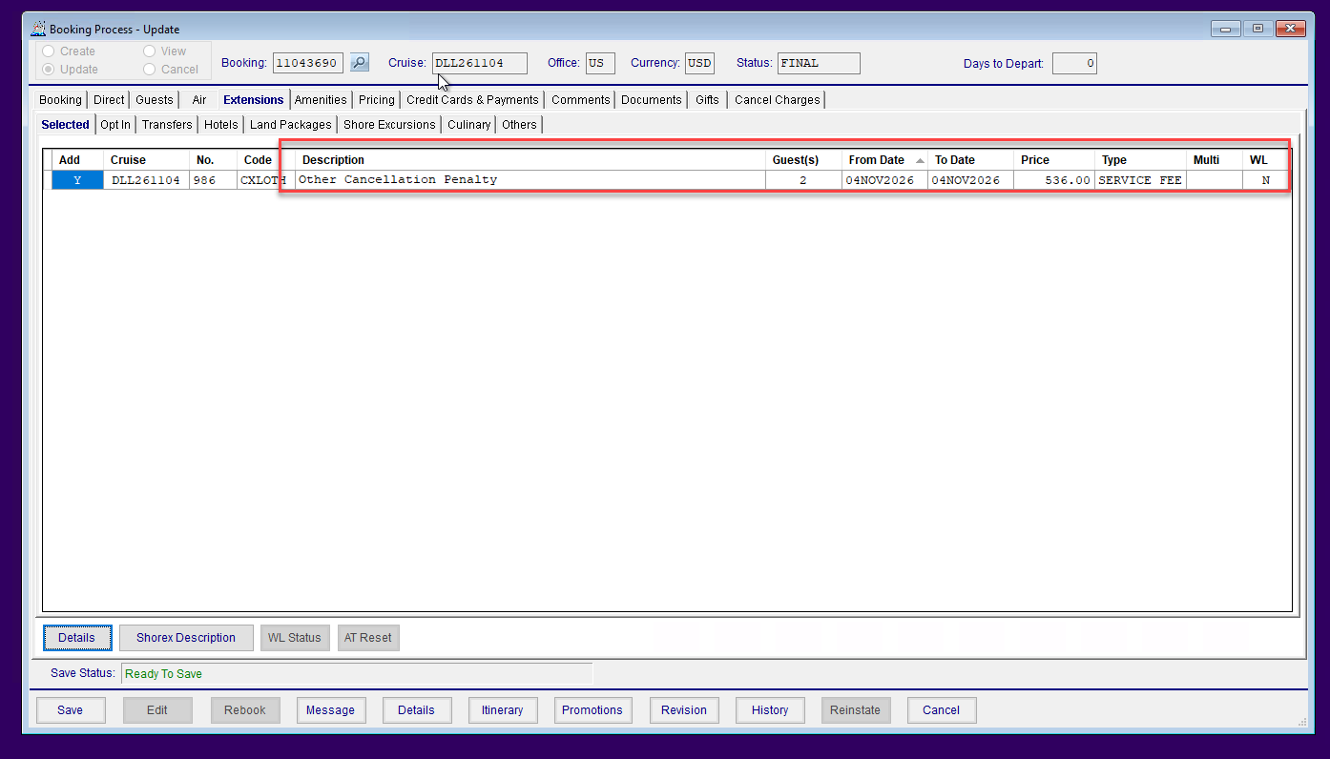
- Validate vouchers applied to the removed shorex are correctly removed from the TotalRemovedExtnCost
11043693
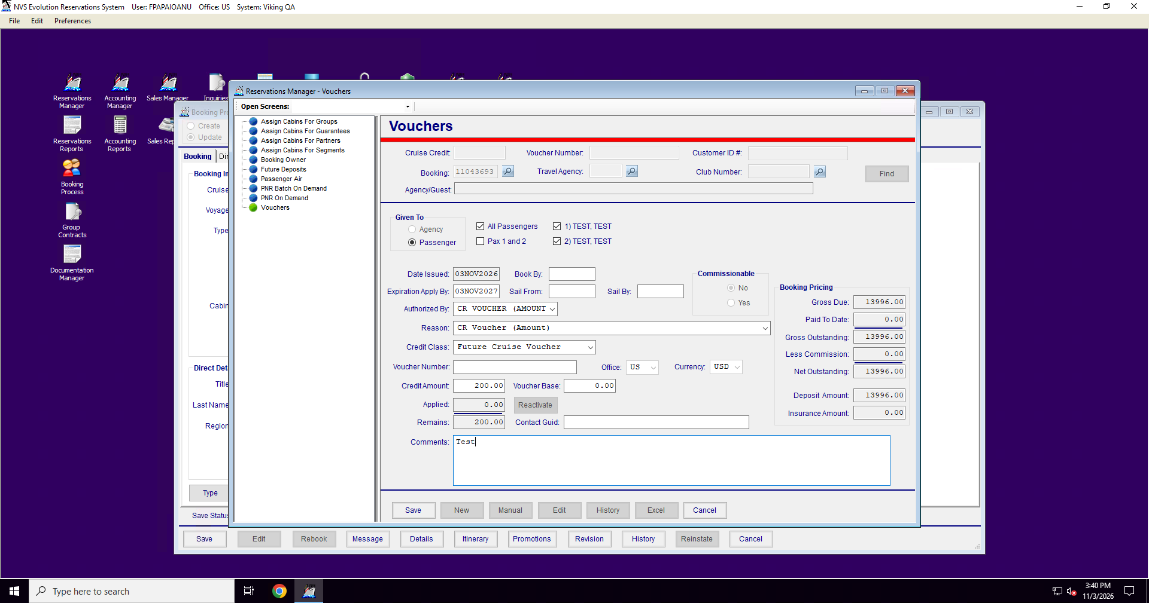
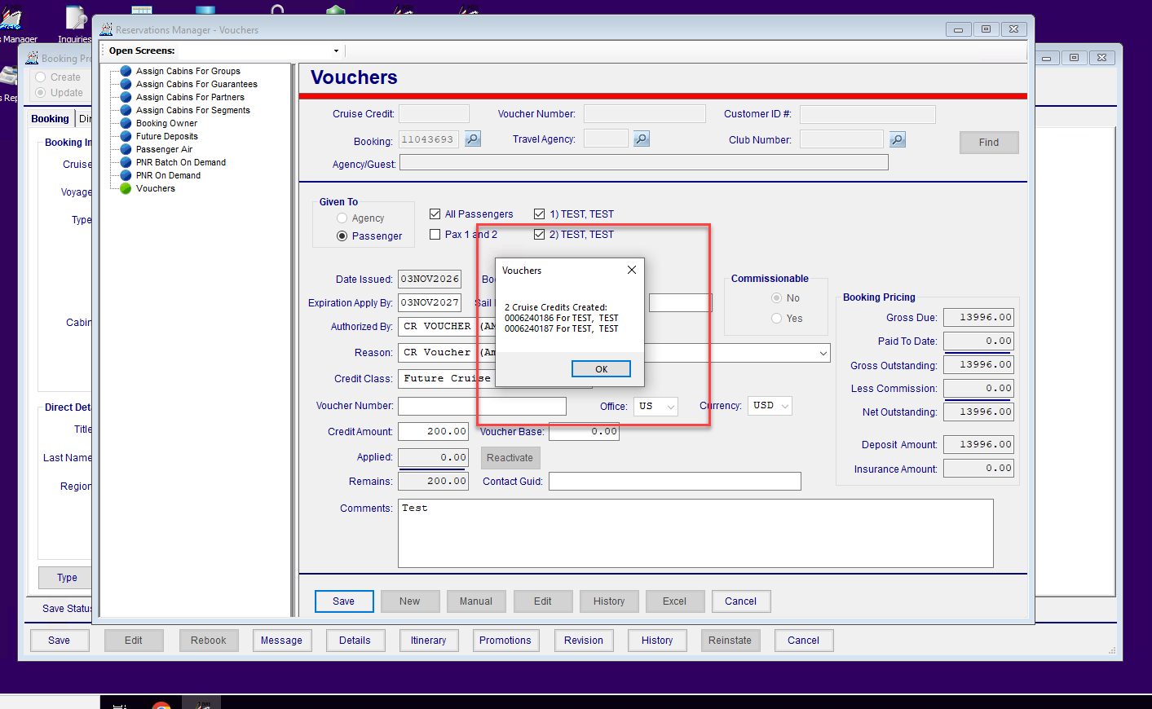
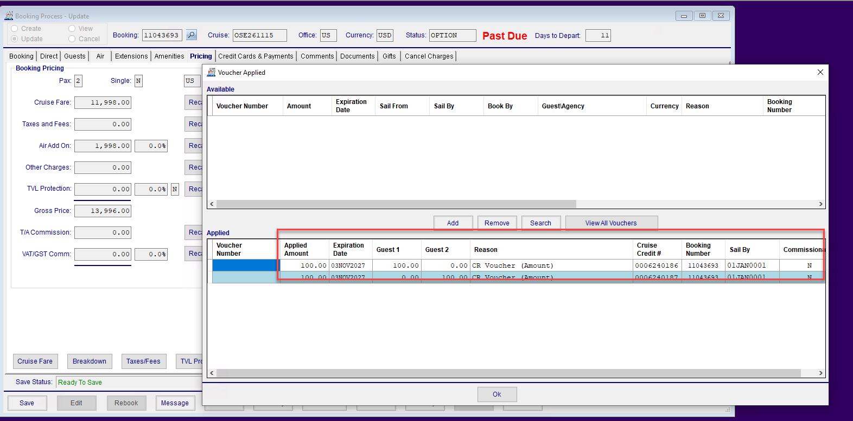
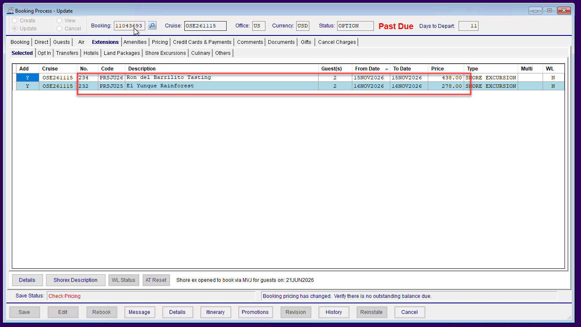
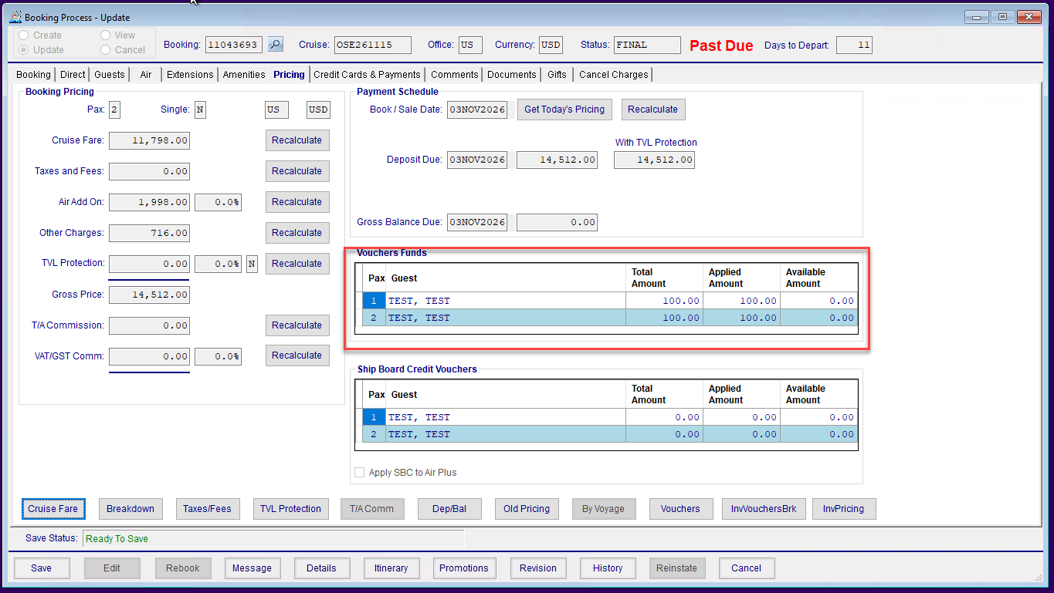
- Validate if the shorex price was reduced at the time it was added, that the TotalRemovedExtnCostcorrectly pulls from the price the shorex was added at, not the cruise’s build price
<RemoveExtensionsRequest>
<MessageHeader>
<MessageId>REMEXTREQ</MessageId>
<Version>1.0</Version>
<UserID>FPAPAIOANU</UserID>
<UserName>franklin.papaioanu@viking.com</UserName>
<UICode>C</UICode>
<GDSCode>CS</GDSCode>
<AgencyId></AgencyId>
<AgentIata></AgentIata>
<EmailAddress>franklin.papaioanu@viking.com</EmailAddress>
<SessionID></SessionID>
</MessageHeader>
<MessageBody>
<JSonPayload>{
"Invoice": "11043693",
"UserID": "FPAPAIOANU",
"Comment": "",
"BypassCancelPenalties": false,
"Extensions": [{
"Cruise": "OSE261115",
"Code": "234"
},{
"Cruise": "OSE261115",
"Code": "232",
}
]
}
</JSonPayload>
</MessageBody>
</RemoveExtensionsRequest>

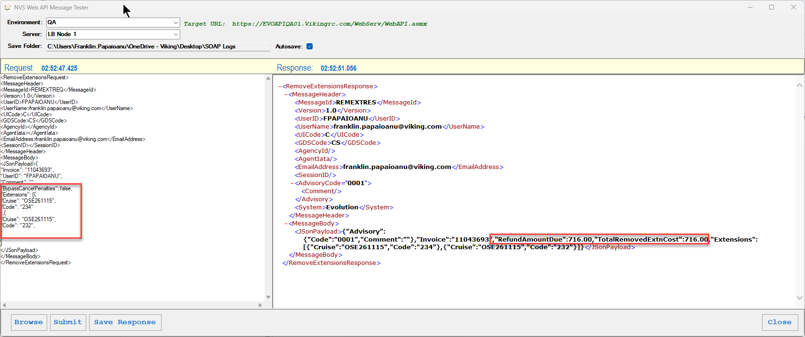
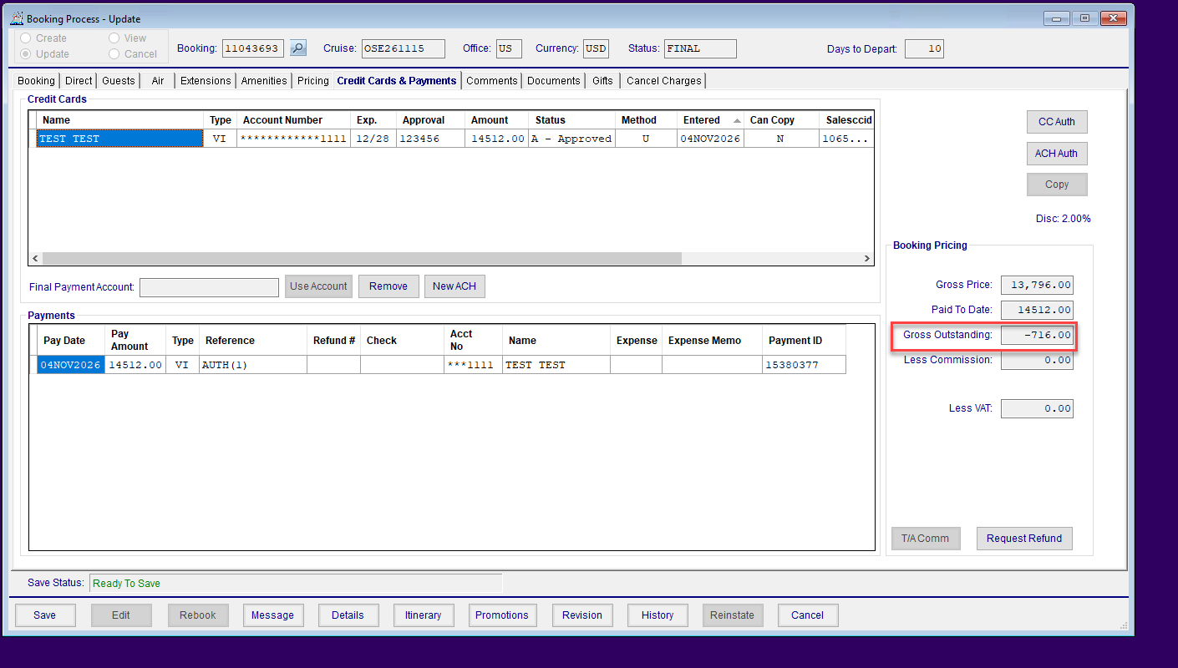

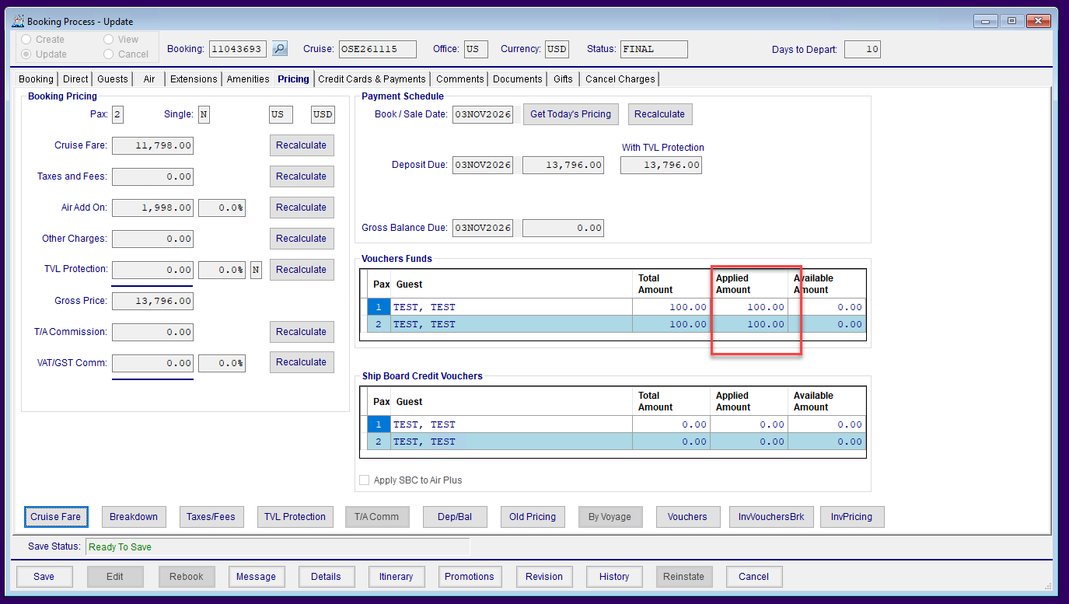
- Validate if cancel penalties are not bypassed, and the shorex are in penalty at the time of removal, that no refund amount will be due, since shorex get penalized at 100% if they are under penalty

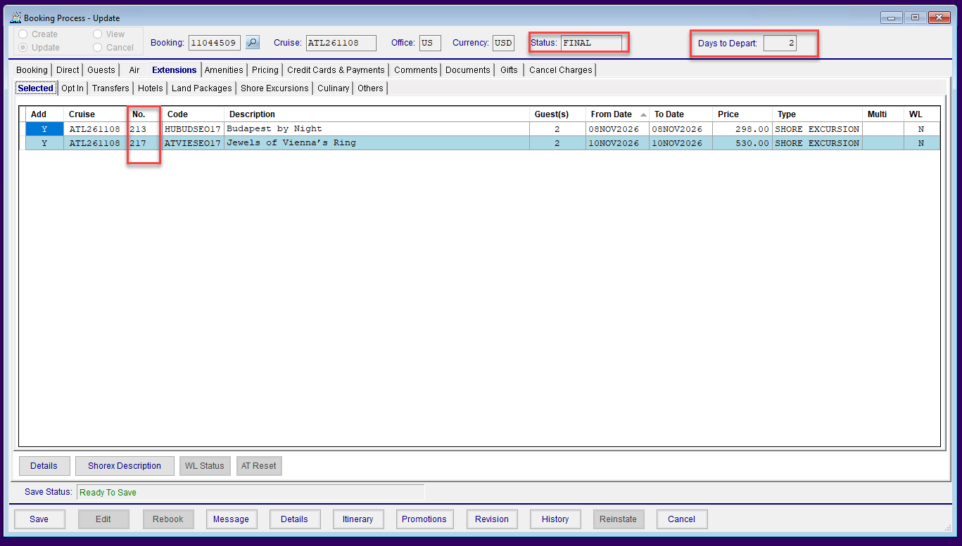
<RemoveExtensionsRequest>
<MessageHeader>
<MessageId>REMEXTREQ</MessageId>
<Version>1.0</Version>
<UserID>FPAPAIOANU</UserID>
<UserName>franklin.papaioanu@viking.com</UserName>
<UICode>C</UICode>
<GDSCode>CS</GDSCode>
<AgencyId></AgencyId>
<AgentIata></AgentIata>
<EmailAddress>franklin.papaioanu@viking.com</EmailAddress>
<SessionID></SessionID>
</MessageHeader>
<MessageBody>
<JSonPayload>{
"Invoice": "11044509",
"UserID": "FPAPAIOANU",
"Comment": "",
"BypassCancelPenalties": true,
"Extensions": [{
"Cruise": "ATL261108",
"Code": "213"
},{
"Cruise": "ATL261108",
"Code": "217",
}
]
}
</JSonPayload>
</MessageBody>
</RemoveExtensionsRequest>
- Please validate the correct amount is returned regardless of booking statuses (except cancelled)

Confirmed:
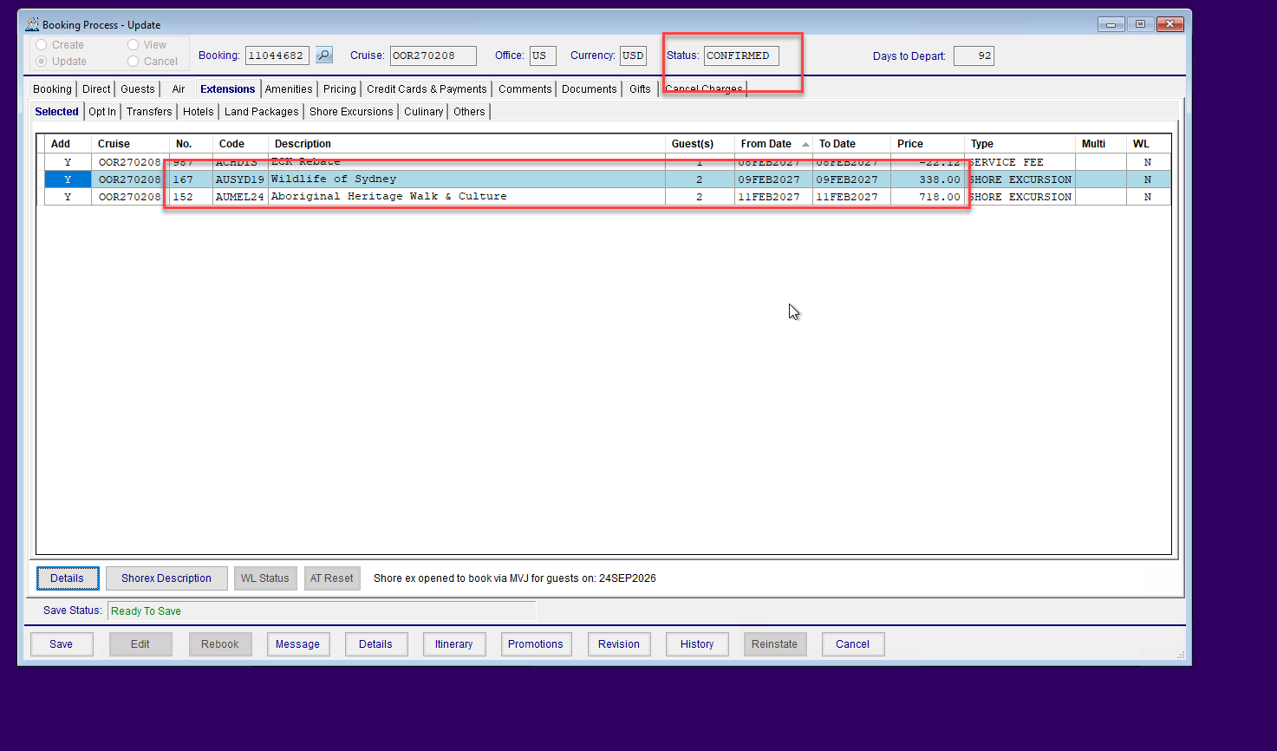
<RemoveExtensionsRequest>
<MessageHeader>
<MessageId>REMEXTREQ</MessageId>
<Version>1.0</Version>
<UserID>FPAPAIOANU</UserID>
<UserName>franklin.papaioanu@viking.com</UserName>
<UICode>C</UICode>
<GDSCode>CS</GDSCode>
<AgencyId></AgencyId>
<AgentIata></AgentIata>
<EmailAddress>franklin.papaioanu@viking.com</EmailAddress>
<SessionID></SessionID>
</MessageHeader>
<MessageBody>
<JSonPayload>{
"Invoice": "11044682",
"UserID": "FPAPAIOANU",
"Comment": "",
"BypassCancelPenalties": false,
"Extensions": [{
"Cruise": "OOR270208",
"Code": "152"
},{
"Cruise": "OOR270208",
"Code": "167",
}
]
}
</JSonPayload>
</MessageBody>
</RemoveExtensionsRequest>
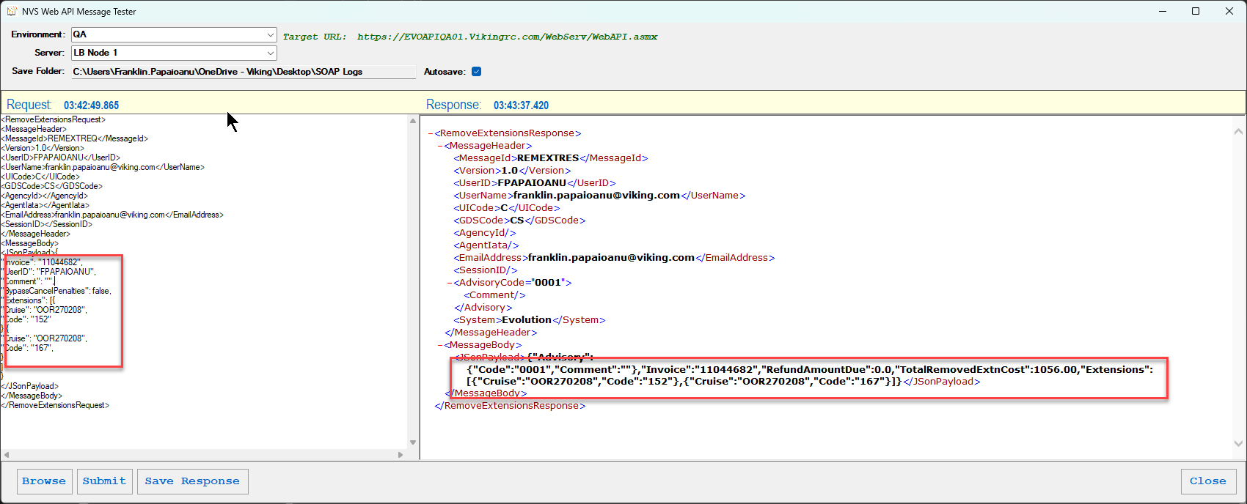
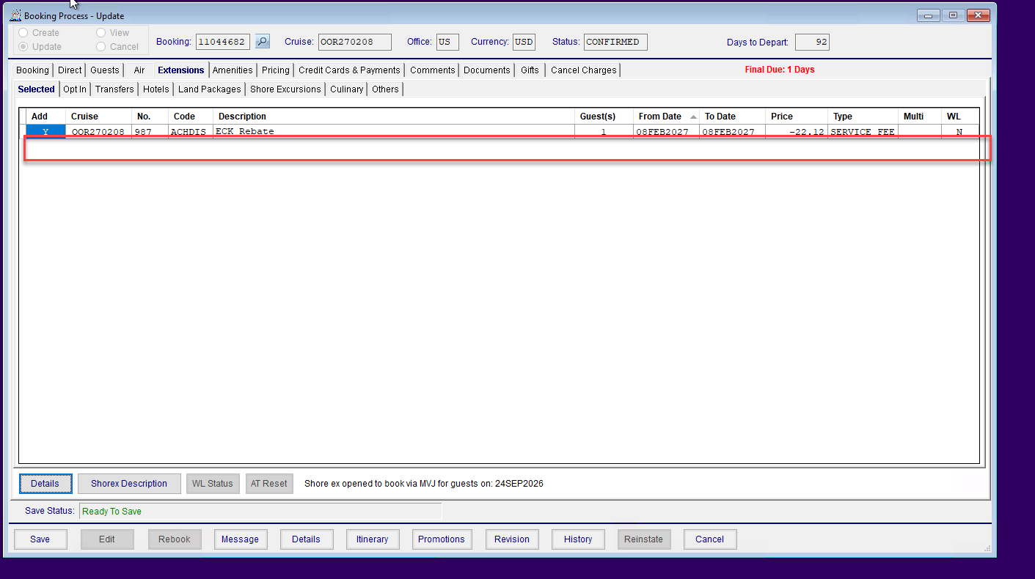
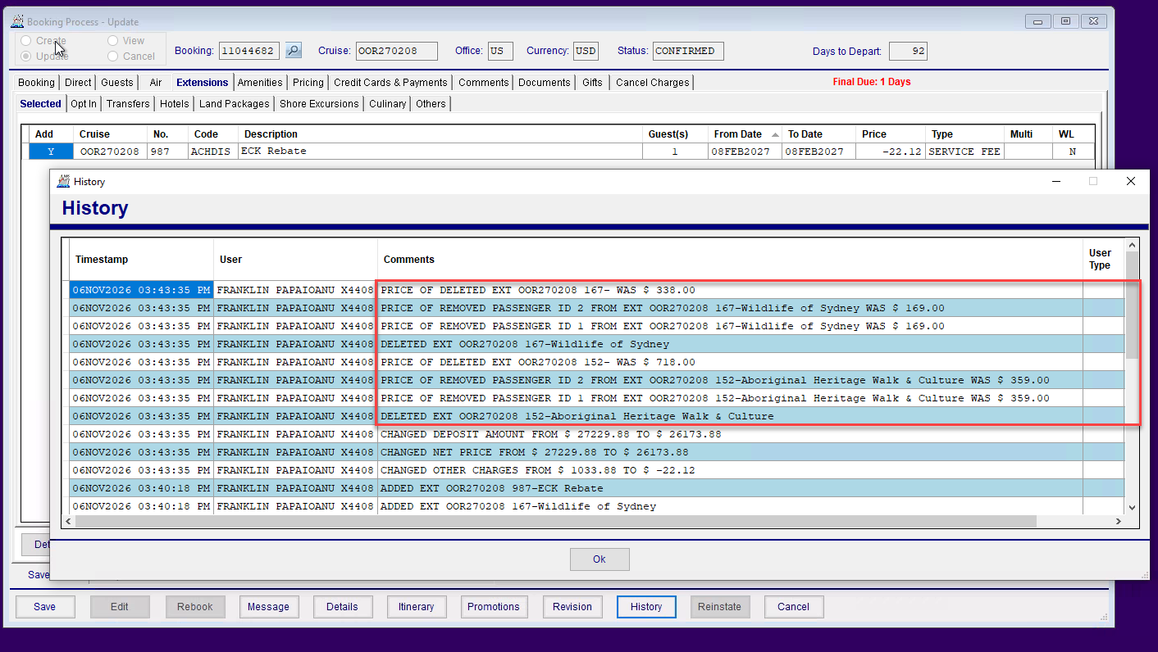
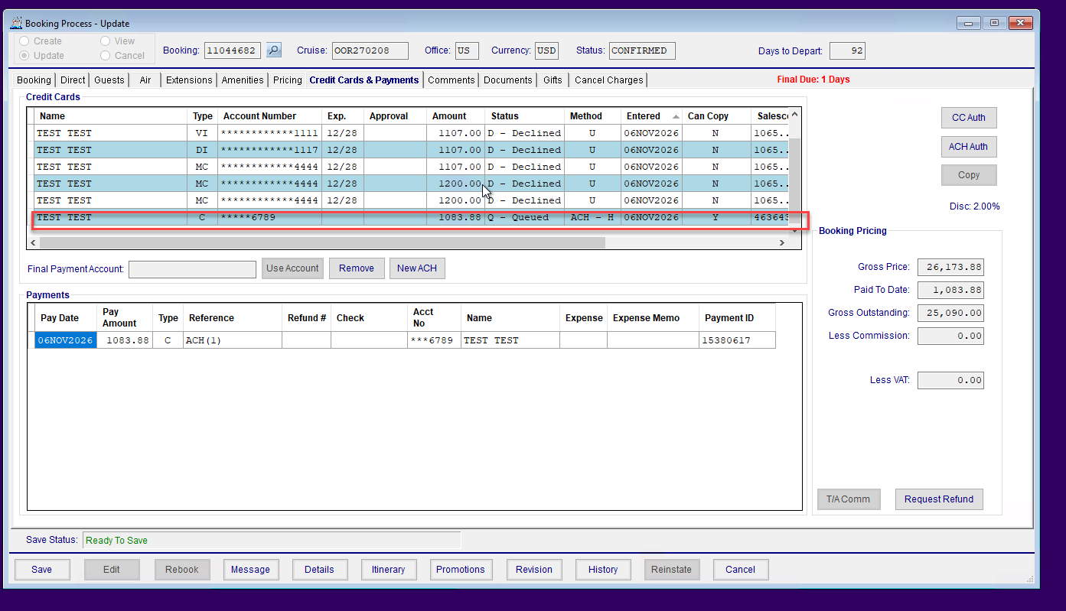
Option:
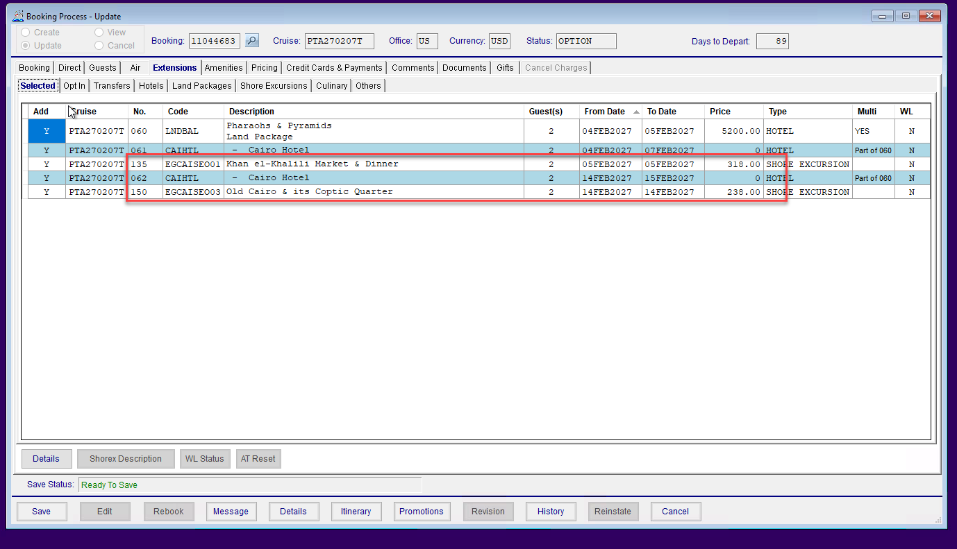
<RemoveExtensionsRequest>
<MessageHeader>
<MessageId>REMEXTREQ</MessageId>
<Version>1.0</Version>
<UserID>FPAPAIOANU</UserID>
<UserName>franklin.papaioanu@viking.com</UserName>
<UICode>C</UICode>
<GDSCode>CS</GDSCode>
<AgencyId></AgencyId>
<AgentIata></AgentIata>
<EmailAddress>franklin.papaioanu@viking.com</EmailAddress>
<SessionID></SessionID>
</MessageHeader>
<MessageBody>
<JSonPayload>{
"Invoice": "11044683 ",
"UserID": "FPAPAIOANU",
"Comment": "",
"BypassCancelPenalties": false,
"Extensions": [{
"Cruise": "PTA270207T",
"Code": "135"
},{
"Cruise": "PTA270207T",
"Code": "150",
}
]
}
</JSonPayload>
</MessageBody>
</RemoveExtensionsRequest>

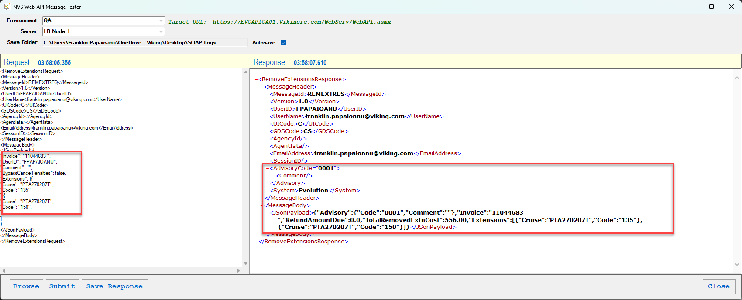
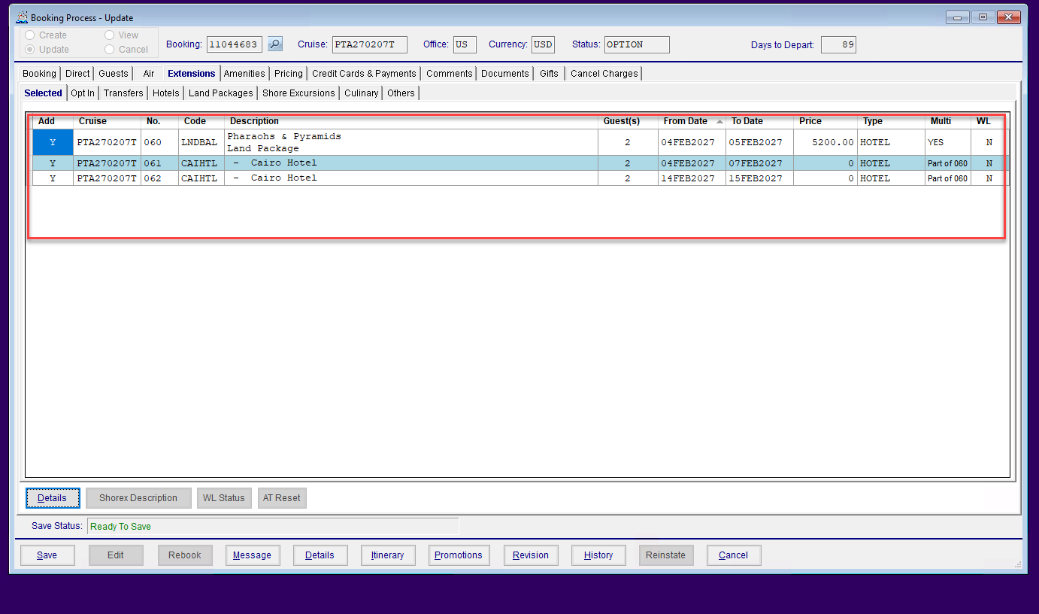
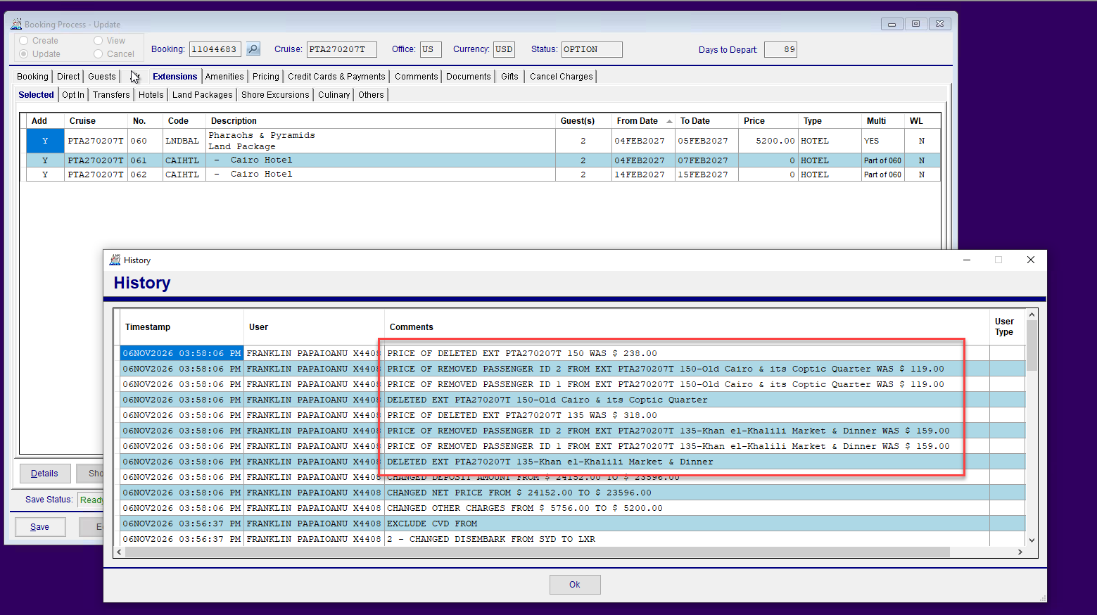
- Please regression test no changes were made to the other parameters in the response from ticket https://vikingtravel.atlassian.net/browse/RS-21108
Missing Invoice: 11044683
<RemoveExtensionsRequest>
<MessageHeader>
<MessageId>REMEXTREQ</MessageId>
<Version>1.0</Version>
<UserID>FPAPAIOANU</UserID>
<UserName>franklin.papaioanu@viking.com</UserName>
<UICode>C</UICode>
<GDSCode>CS</GDSCode>
<AgencyId></AgencyId>
<AgentIata></AgentIata>
<EmailAddress>franklin.papaioanu@viking.com</EmailAddress>
<SessionID></SessionID>
</MessageHeader>
<MessageBody>
<JSonPayload>{
"Invoice": " ",
"UserID": "FPAPAIOANU",
"Comment": "",
"BypassCancelPenalties": false,
"Extensions": [{
"Cruise": "PTA270207T",
"Code": "135"
},{
"Cruise": "PTA270207T",
"Code": "150",
}
]
}
</JSonPayload>
</MessageBody>
</RemoveExtensionsRequest>

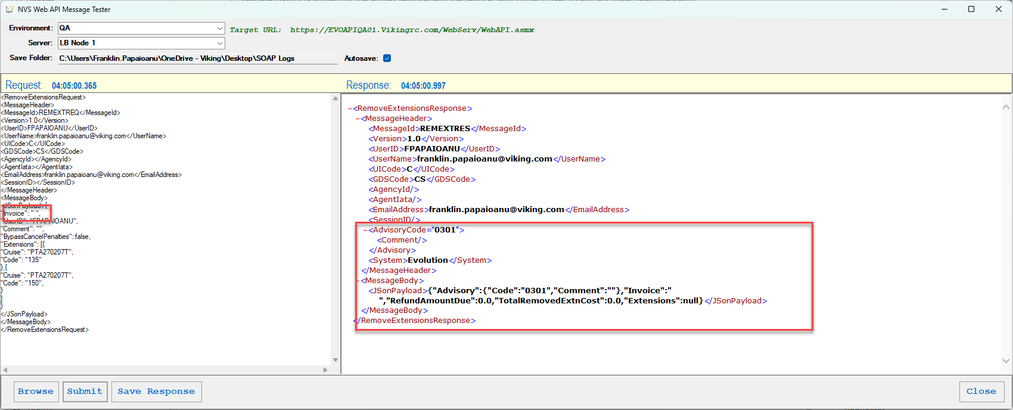

<RemoveExtensionsRequest>
<MessageHeader>
<MessageId>REMEXTREQ</MessageId>
<Version>1.0</Version>
<UserID>FPAPAIOANU</UserID>
<UserName>franklin.papaioanu@viking.com</UserName>
<UICode>C</UICode>
<GDSCode>CS</GDSCode>
<AgencyId></AgencyId>
<AgentIata></AgentIata>
<EmailAddress>franklin.papaioanu@viking.com</EmailAddress>
<SessionID></SessionID>
</MessageHeader>
<MessageBody>
<JSonPayload>{
"Invoice": "11044683 ",
"UserID": "FPAPAIOANU",
"Comment": "",
"BypassCancelPenalties": false,
"Extensions": [{
"Cruise": "",
"Code": "135"
},{
"Cruise": "PTA270207T",
"Code": "150",
}
]
}
</JSonPayload>
</MessageBody>
</RemoveExtensionsRequest>

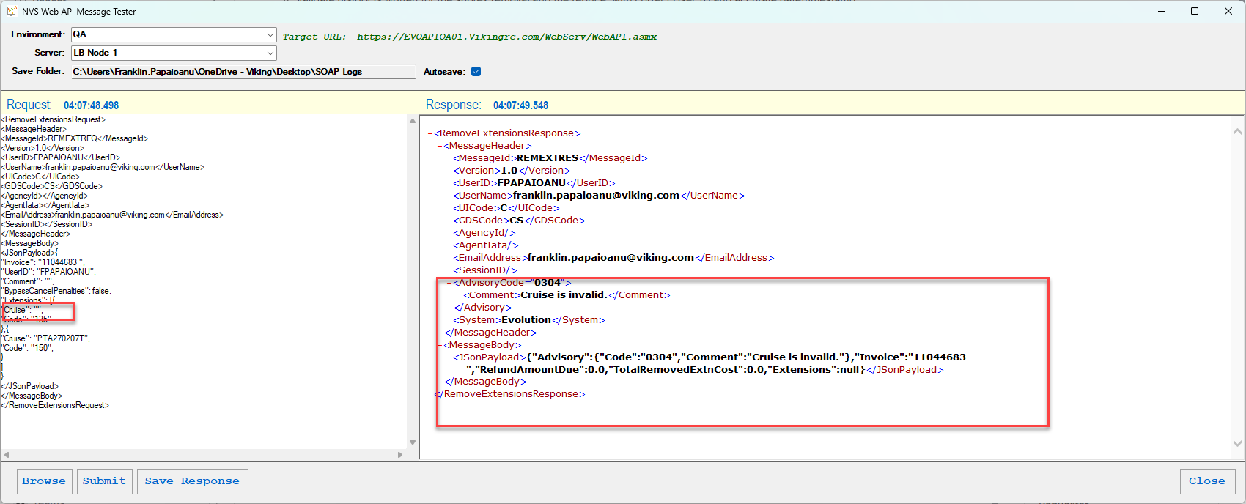

<RemoveExtensionsRequest>
<MessageHeader>
<MessageId>REMEXTREQ</MessageId>
<Version>1.0</Version>
<UserID>FPAPAIOANU</UserID>
<UserName>franklin.papaioanu@viking.com</UserName>
<UICode>C</UICode>
<GDSCode>CS</GDSCode>
<AgencyId></AgencyId>
<AgentIata></AgentIata>
<EmailAddress>franklin.papaioanu@viking.com</EmailAddress>
<SessionID></SessionID>
</MessageHeader>
<MessageBody>
<JSonPayload>{
"Invoice": "11044683 ",
"UserID": "FPAPAIOANU",
"Comment": "",
"BypassCancelPenalties": false,
"Extensions": [{
"Cruise": "PTA270207T",
"Code": ""
},{
"Cruise": "PTA270207T",
"Code": "150",
}
]
}
</JSonPayload>
</MessageBody>
</RemoveExtensionsRequest>
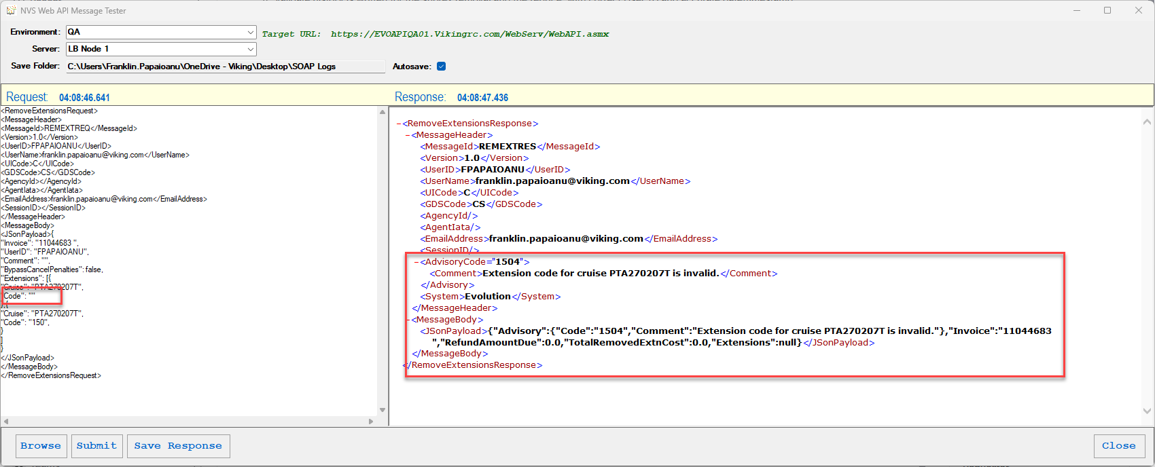Missing User ID:
<RemoveExtensionsRequest>
<MessageHeader>
<MessageId>REMEXTREQ</MessageId>
<Version>1.0</Version>
<UserID>FPAPAIOANU</UserID>
<UserName>franklin.papaioanu@viking.com</UserName>
<UICode>C</UICode>
<GDSCode>CS</GDSCode>
<AgencyId></AgencyId>
<AgentIata></AgentIata>
<EmailAddress>franklin.papaioanu@viking.com</EmailAddress>
<SessionID></SessionID>
</MessageHeader>
<MessageBody>
<JSonPayload>{
"Invoice": "11044683 ",
"UserID": "",
"Comment": "",
"BypassCancelPenalties": false,
"Extensions": [{
"Cruise": "PTA270207T",
"Code": "135"
},{
"Cruise": "PTA270207T",
"Code": "150",
}
]
}
</JSonPayload>
</MessageBody>
</RemoveExtensionsRequest>



